- Ensure your master branch is clean:
- Create a new branch named GitWork and switch to it
- Create a file named hello.xml with some content
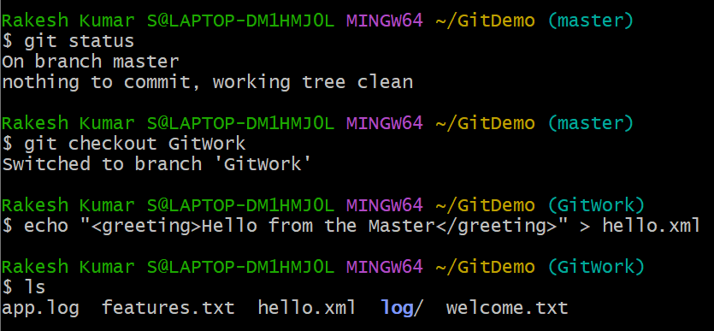
- Switch back to your master trunk
- Create the identical file (hello.xml) but add different content
- Observe the log to see how the two branches have diverged
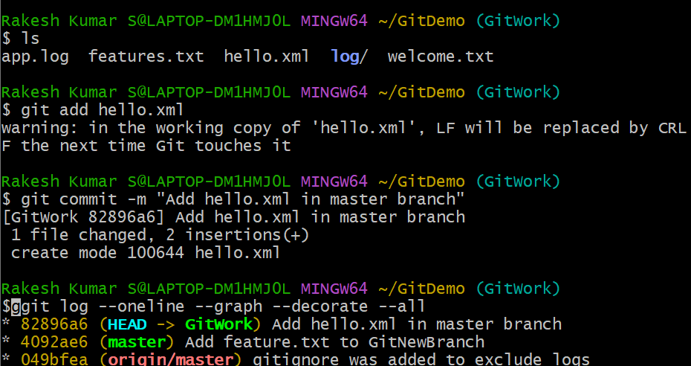

- Attempt to merge the GitWork branch into master branch
- Check the status to see the unmerged path
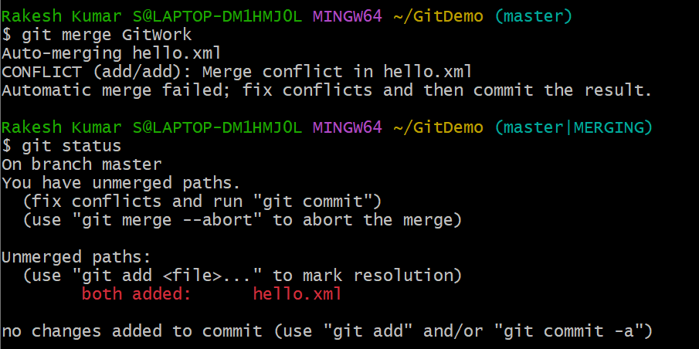
- Open the conflicted file in Notepad++
- Delete the markers and save it to resolve the conflict
- Then add and commit the file
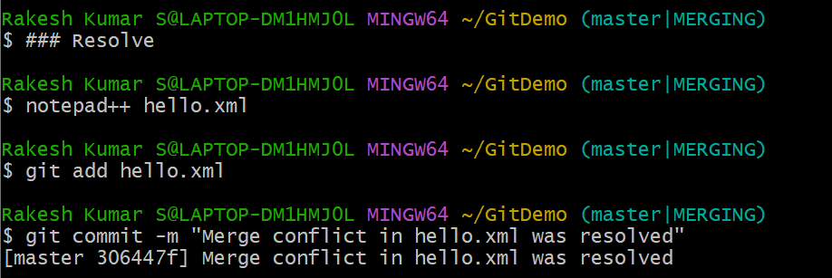

- Sometimes merge tools create backup files ending in .orig. Update the .gitignore file to ignore it.
